Using Responsive Layout Creator

Introduction
The Responsive Layout Creator is intended to be able to quickly make HTML layouts using responsive design so that the resulting web page is usable in wide screens, tablets, and smart phones.

Steps
Using the Responsive Layout Creator to create responsive HTML pages consists of the following main tasks:
- Determine the required layout elements on the page.
- Run the Responsive Layout Creator and do the following tasks:
  - Move the required layout elements to from the “Available Layout Elements” to the “Selected Layout Elements” list.
  - Provide the settings in the “Title and Meta Information” section.
  - Use the “Save to HTML File” to save the selected layout to the desired HTML file name.
- Run the Blue Griffon editor (WYSIWYG editor friendly to responsive layouts) and do the following tasks:
  - Open the HTML file created with Responsive Layout Creator as described above.
  - Replace the markers in the layout with the actual text content or images. For example replace “Small Image goes here” with an image pasted from the source or replace “Content goes Here” with the actual text content.
  - Save the edited HTML file.
- Test the HTML file in a local browser.
- Upload the HTML file to your website.
The details about each of these steps are shown below.

Determine Layout Elements Required
The layout elements are made available in Responsive Layout Creator with labels such as “Banner”, “Facebook Like”, and “Small Image Left | Text”. The first step is to determine which elements are required on the page. For example on a web page shown below the layout elements that are required are divided into vertical slices, labeled as “Banner”, “Blog Image”, “Facebook Like”, etc.
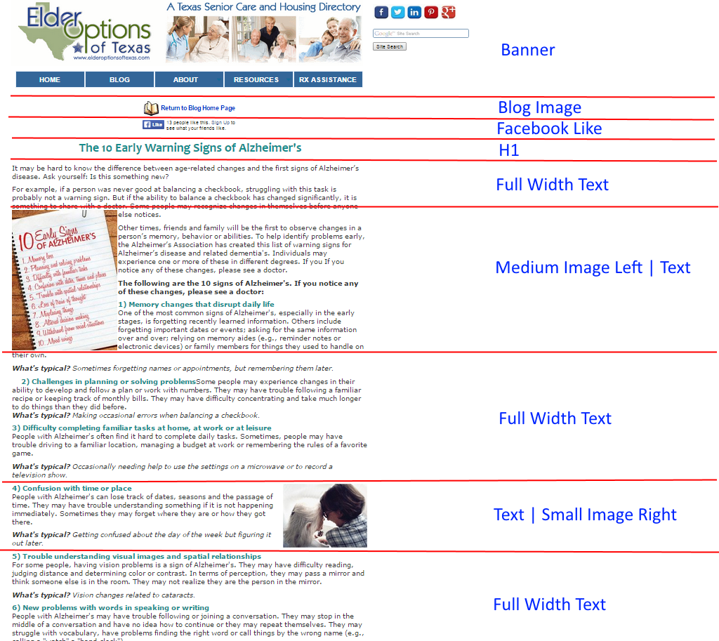
Each of the slices represent some element on the page that potentially will need to be treated specially in the markup for the responsive web page. In particular images that are commingled with the text will need to be given special layouts that describe the situation, e.g. “Media Image Left | Text” to allow the text to be separated from the image for the narrow layouts such as smart phones.

Responsive Layout Creator
Start the Responsive Layout Creator application by clicking on the application icon:
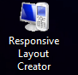

Select the Layout Elements
Based on the layout elements determined from the previous step, use the list boxes in Responsive Layout Creator to move the desired elements to the Selected Layout Elements list as shown below:
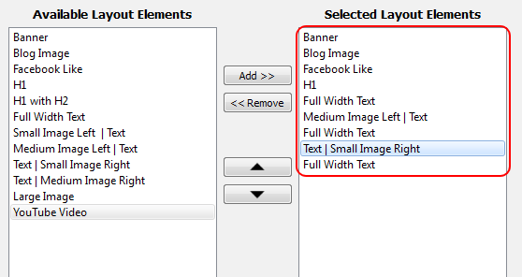
The Add >> and << Remove buttons can be used to move the elements to and from the Selected Layout Elements list. The up and down arrows can then be used to position the elements in the correct vertical order to match that in the required elements obtained in the first step. Note that it is often required for some elements to occur multiple times, for example “Full Width Text” element occurs three times.

Set the Title and Meta Information
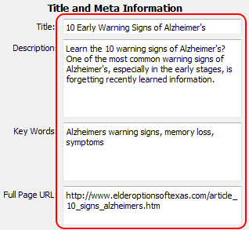
The Title and Meta Information for the page can then be supplied in the text boxes on the right-side of the application window as shown below:
The Title, Description, and Key Words entries correspond to the meta information that is given in the header of the HTML, and can be copied directly if an existing page is being updated. For example by using right-mouse-click View Source on the web page the existing meta can be located and copied as shown below:
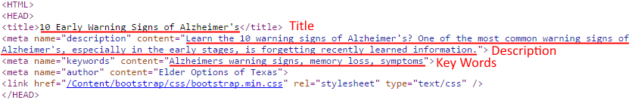
For new web pages the information will be input as required for the meta information about the page for the purposes of providing information to the web crawlers for search engines.
The Full Page URL setting is to provide the full URL of the page as it will appear in the website. This is used by the Facebook Like layout element and any other elements that might need the full website URL.
The YouTube iFrame setting is to provide the embedded link to a YouTube video and will be similar to the following:
<iframe src="http://www.youtube.com/embed/Oa8fpUx7dTs" allowfullscreen="" frameborder="0" height="315" width="560"></iframe>

Save to the HTML File
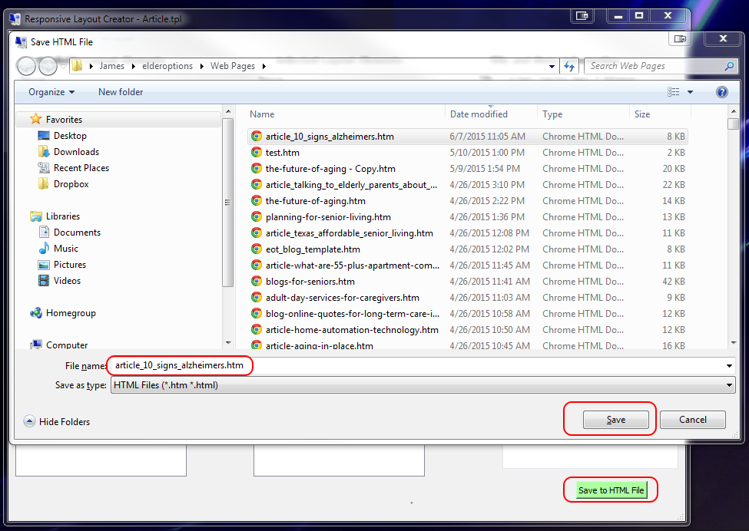
Use the Save to HTML File button in the lower right of the application to save the layout and setting to the HTML file using the Save HTML File popup as shown below:

Select the appropriate folder and then give the file the name and “.htm” or “.html” extension and then click the Save button. An informational pop up message will indicate that the file has been properly saved. Any existing file with the same name will be backed up with a “.bak” extension.

Blue Griffon Editor
Start the Blue Griffon Editor by clicking on the Blue Griffon icon:
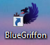
Open the file that was previously saved by the Responsive Layout Creator by selecting the File > Open File menu and then selecting the file that was saved. Once the file is opened make sure the WYSIWYG option is chosen in the bottom of the Window:
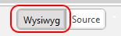
The editor will show the layout with the layout sections shown separated by comments highlighted in yellow as shown below:
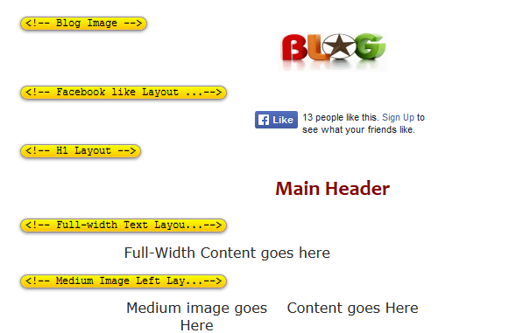
There are also place holders such as “Full-Width Content goes here” and “Medium image goes Here” to guide the placement of the actual content that will replace the place holders. Examples will be given on how to replace the place holders below.

Replace Main Header Place Holder
The “Main Header” place holder can be replaced by bringing up the existing web page in the Chrome browser and selecting the header text on the web page and then right-mouse-click to select the “Copy” command as shown below:
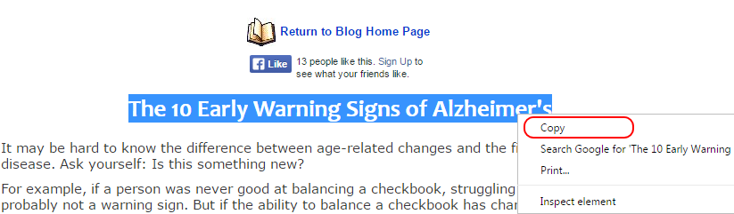
Then in the BlueGriffon window replace the “Main Header” place holder by selecting it and use the right-mouse Paste without Formatting command to replace it with the copied text:
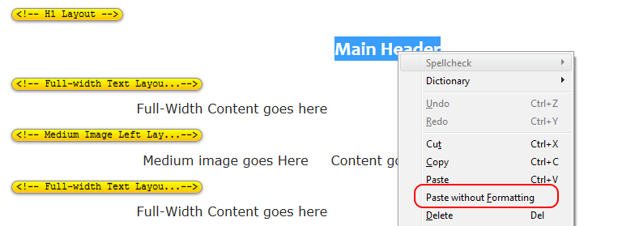
The Paste without Formatting option is used for the Header text to ensure that the pre-defined formatting of the header is maintained.

Replace Full-Width Content
In the browser select all of the content that is below the header but above the area where the image is embedded, select it, and use the right-mouse copy command:
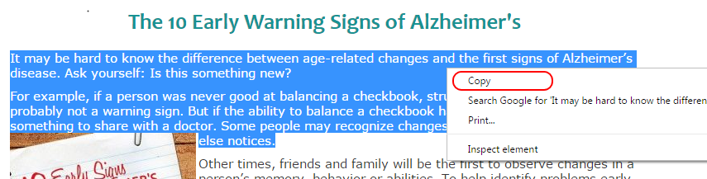
Then in the BlueGriffon editor select the corresponding Full-Width Content goes here text then use the right-mouse Paste command to replace it with the copied content:
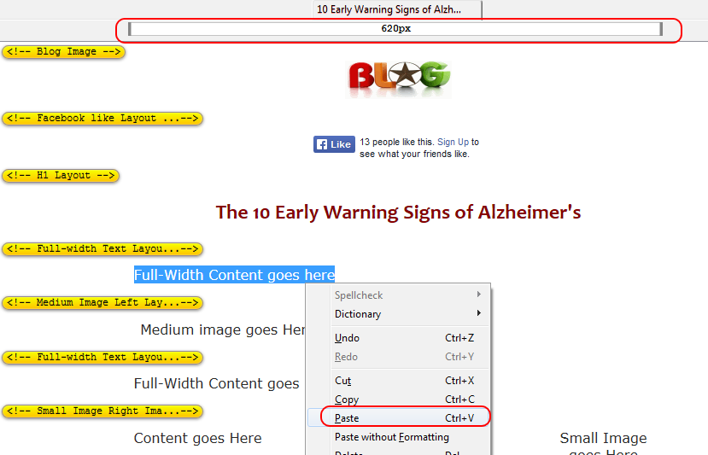
The main difference from the header is that the normal Paste command is used so as to preserve the formatting in the copied text. When selecting the text it is good to ensure that the width at the top is as expected, in this case 620px.

Replace Medium Image Left
In the browser select the medium image on the left below the full-width content that was previously selected, then use the right-mouse Copy image command to copy the image:
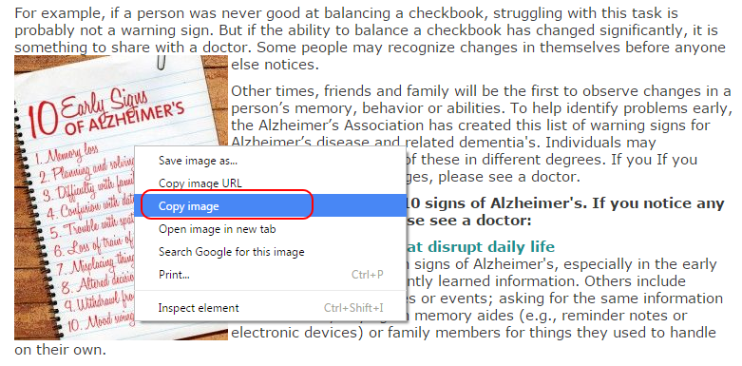
Then in the BlueGriffon editor select the corresponding Medium Image goes here text then use the right-mouse Paste command to replace it with the copied image:
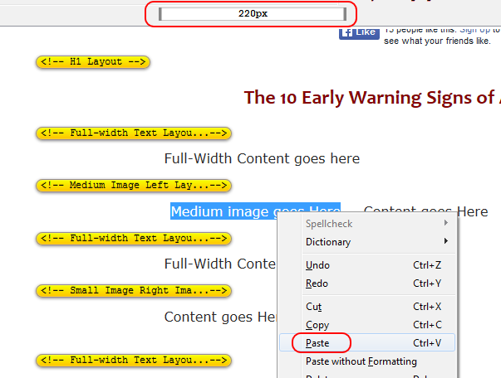
When pasting be sure to watch the indicator in the top to be sure the correct width is selected, in this case 200px.
Next in the browser select the text to the right of the image, being sure that it includes the whole paragraphs, and use the Copy command to copy the content:
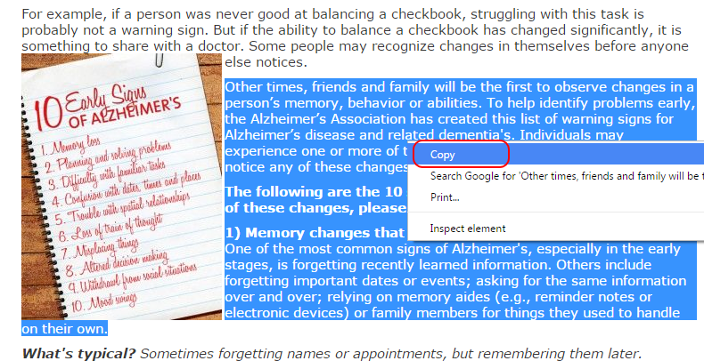

Then in the BlueGriffon editor select the Content goes here to the right of the image and use the Paste command to paste the content in the area, ensuring that the corresponding width at the top matches the selection, in this case 380px:
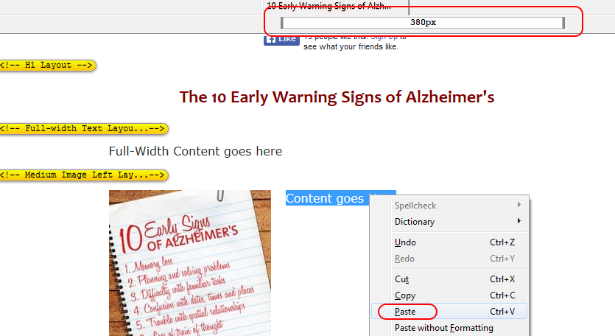

Replace Remaining Layout Sections
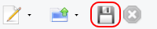
Continue with the pattern of copy and paste as shown in the examples above and fill in the remaining layout sections all the way to the bottom of the page. Be sure to use the Save command to save the final HTML file.

Test the HTML File in the Browser
Use the preview icon on the top right to preview the results in the browser:
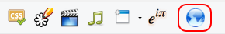
First make the browser full width to ensure that the page looks OK in that mode for desktops or laptop screens:
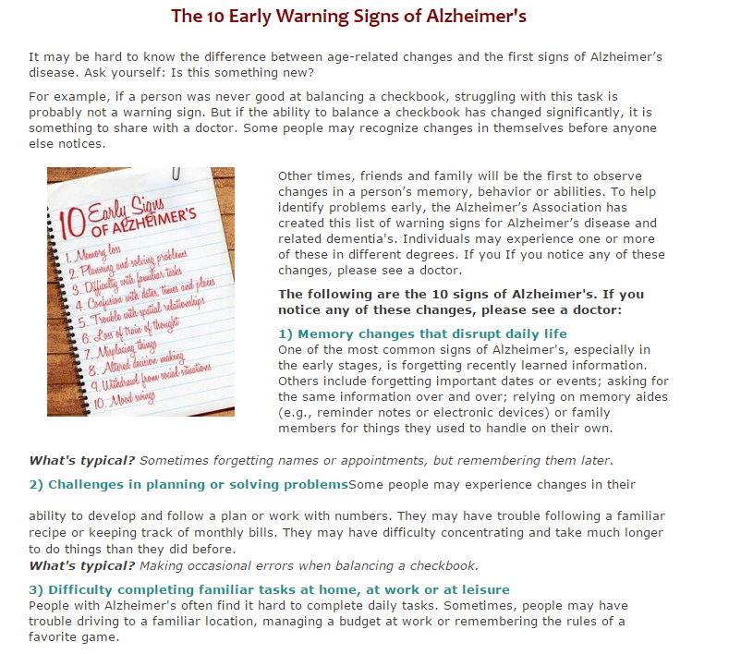
Then narrow the width on the browser to make sure the responsive design is properly rendering the content to fit for tablet and phone widths:
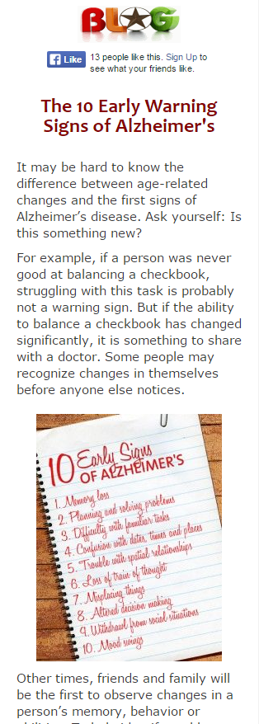
Once the HTML file is fully tested and satisfactory then upload it to the website.

